**Driver Interface**

A system that helps to acknowledge the driver about necessary data at run time.

Our system is a software-controlled system that acquires data from sensors, motor-controller,

myRIO and displays it either on the sequential-light-module or on the OLED.

**SLM (Sequential Light Module)**

It is configured with the motor controller using CAN communication. It has 9 LEDs in a compact array

and uses 2 custom designed PCB’s that help in receiving of data and displaying

it through LED’s on the dashboard. Data from motor-controller is received from the CAN bus by

the MCP2515 ( CAN stand-alone controller) and transmitted to the SLM Master PCB using

SPI communication. The SLM Master PCB then transmits the calibrated data to the SLM Led PCB

which consists of 9 LED’s that glow up sequentially when a certain RPM is reached.

**SLM Master PCB**

SLM Master PCB consists of Atmega2560P IC, which is configured using ArduinoIDE

software, and TLF1963 IC, that regulates 13.2V to 5V using 3.3kohm and 10kohm resistors.

Master PCB is used for receiving the data from CAN bus and transmitting the signals further to

the SLM Led PCB. The PCB designing was done using Eagle software with which Master

PCB of (x mm, y mm) and Led PCB of (x mm, y mm) was designed.

The MCP2515 module reads the CAN frames and filters the CAN payload to obtain the data

from motor controller. This data is then converted to Serial Peripheral Interface (SPI) frames

which are sent to the Atmega2560 microcontroller over the SPI bus. The entire process of

acquiring CAN Bus data from the motor controller to transmitting serial data to

Atmega2560 is programmed into the microcontroller Atmega2560.

Once the serial data is received by the Atmega2560, it stores the data and processes it to transmit

on the SLM Led PCB. Current limiting resistors of 100ohms are used because the LEDs are

rated for 20mA. In the first Master PCB that was designed, we included MCP2515 IC and

TJA1050 transceiver.

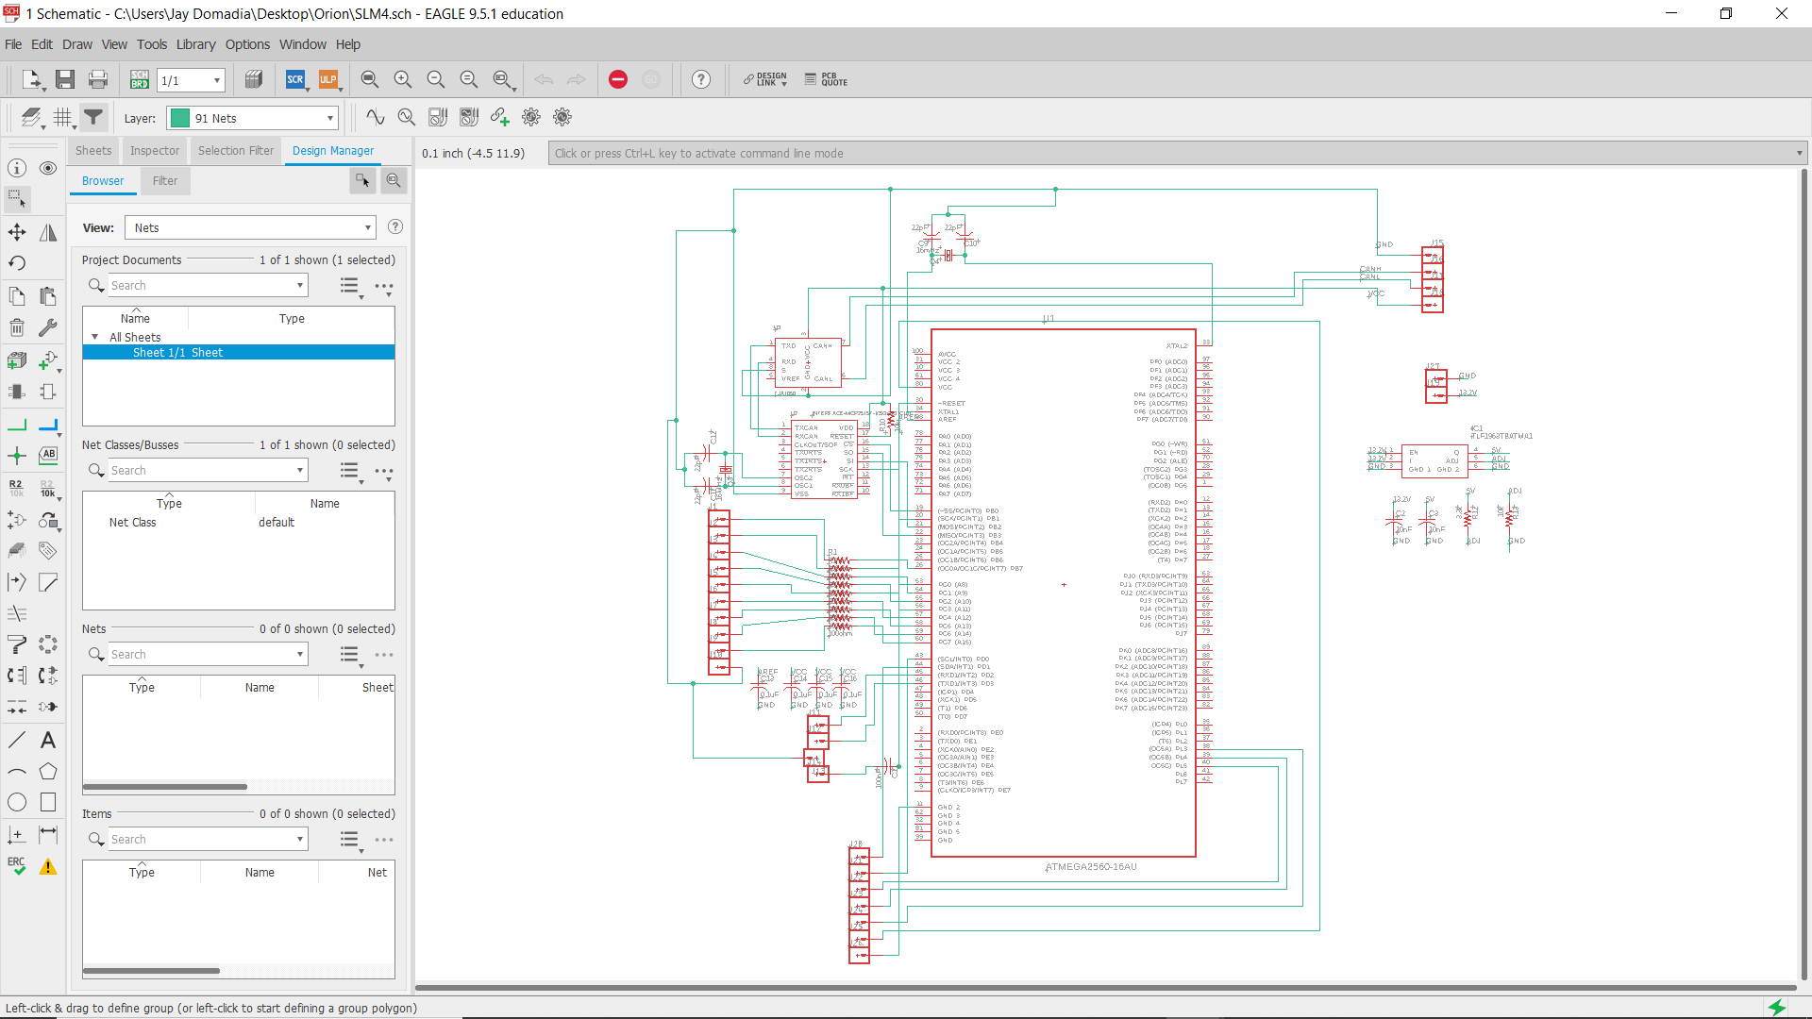

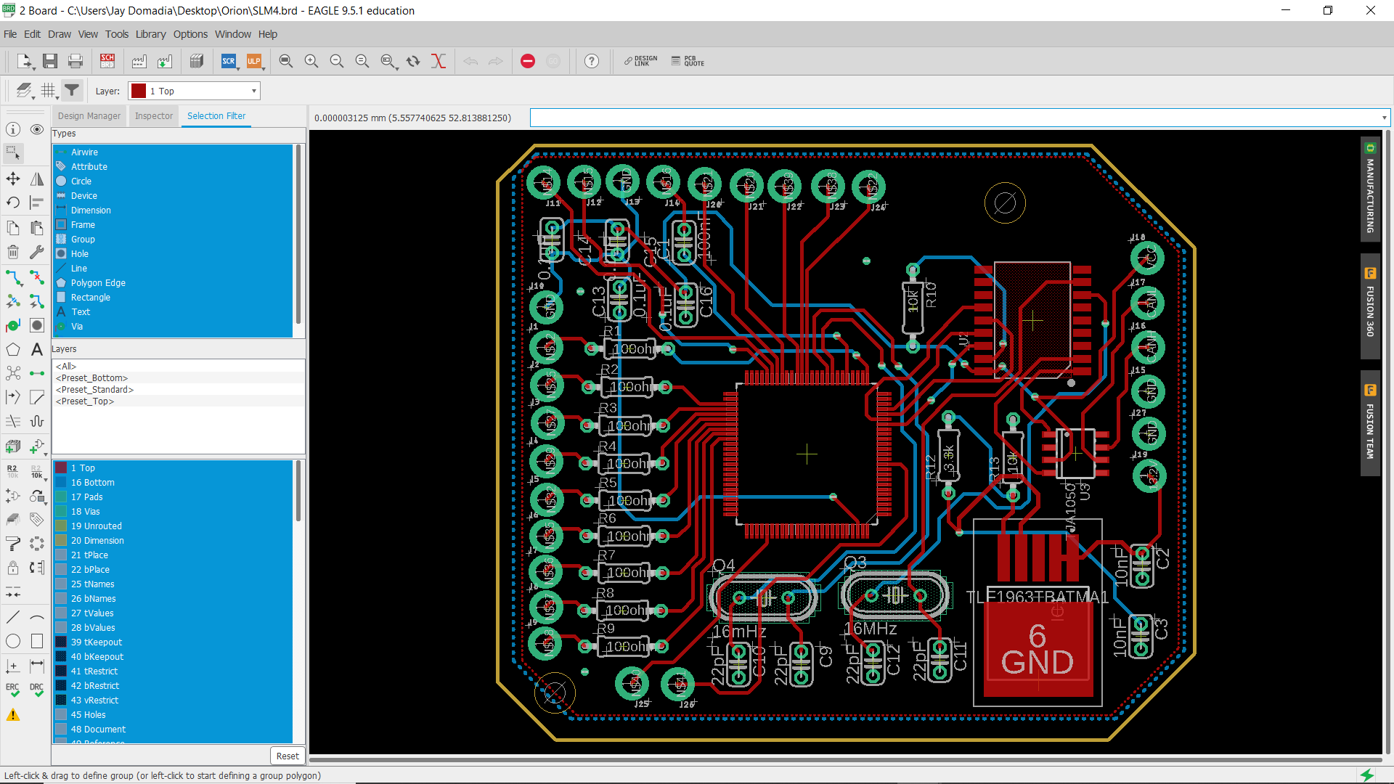

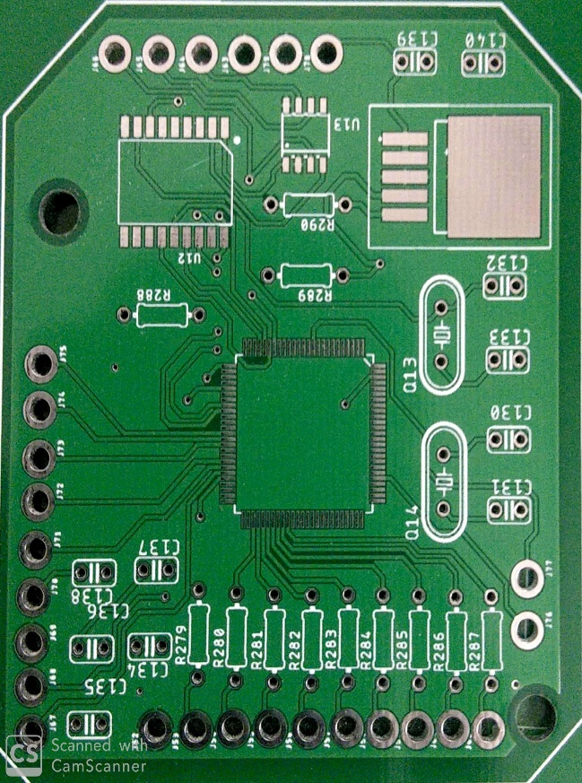

Failure of bootloading the Atmega2560 was faced and selection of wrong connectors was found.

To overcome this failure, new PCB was designed using Eagle, in which the MCP2515 and TJA1050

were replaced by the MCP2515 module because in case of failure of the IC’s, changing the module

was found to be an easy and quicker option. 2nd PCB which was designed, included better choice

of selection of connectors ,which were more reliable and supported locking mechanism,

connector for bootloading, connector for OLED display, reset button.

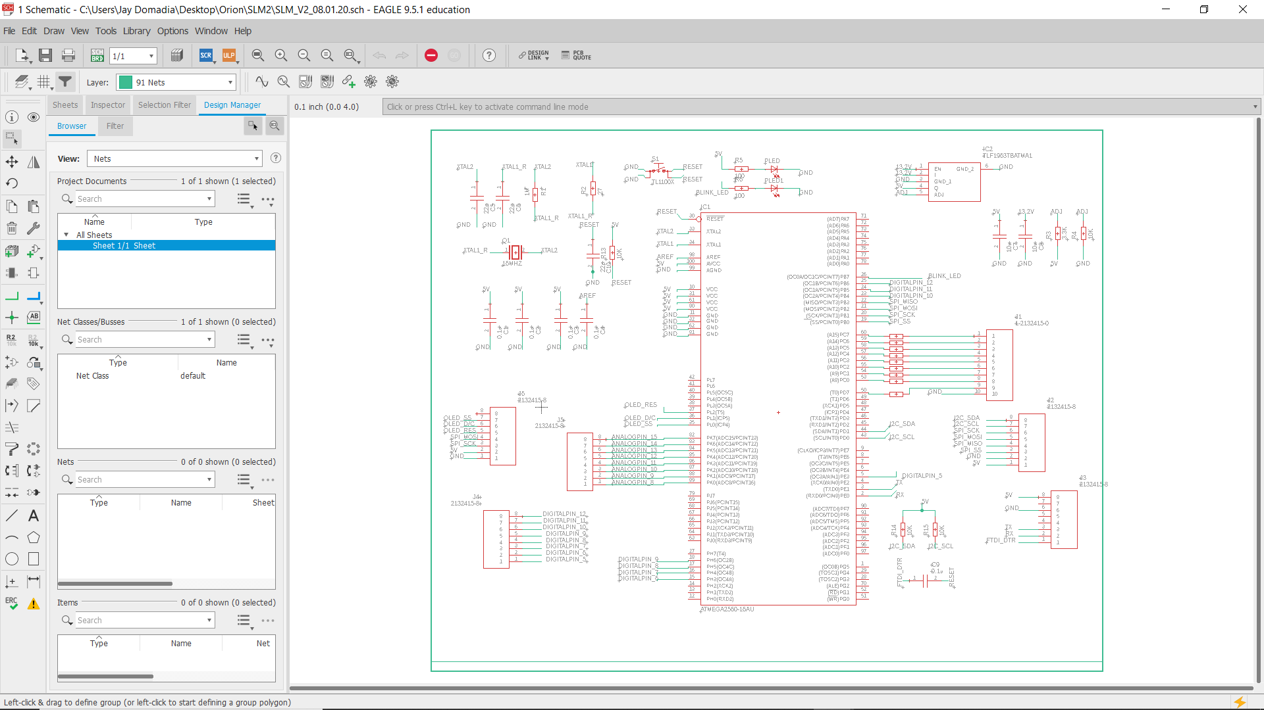

**SLM Led PCB**

SLM Led PCB includes an array 9 LEDs. 3 Green, 3 Yellow and 3 Red LEDs are used

to display the varying RPM at run-time.

